Tour name: 5-Day Grand Journey Across Turkmenistan: Cities, Deserts & Ancient Legends
Tour description: This 5-day journey offers an inspiring introduction to Turkmenistan’s most remarkable highlights, combining monumental architecture, sacred sites, dramatic desert scenery, and the legacy of the ancient Silk Road. From the white-marble grandeur of Ashgabat to the fiery Darvaza Gas Crater, the legendary ruins of Ancient Merv, and the traditional mountain village of Nohur, this tour presents a rich and well-balanced experience of the country’s history, spirituality, and natural beauty.
Starting Point: Ashgabat International Airport
Ending Point: Ashgabat International Airport
Please note: The starting and ending points of the itinerary may be adjusted depending on the client’s request, logistics, and tour format.
Group Size: 3+
Duration: 5 Days
Price: From 905 USD per person
Pricing note: The tour price depends on the number of participants. The more people join the tour, the lower the price per person will be.
Tour itinerary:
Day 1 | Arrival in Ashgabat: The White-Marble Capital  Arrival at Ashgabat International Airport, where you will be met by your guide and transferred to the city.  Begin your discovery of Ashgabat, the capital of Turkmenistan, famous for its monumental scale, broad avenues, elegant urban design, and striking white-marble architecture. Your first visits include the Independence Monument, one of the country’s most important national symbols, and the Neutrality Monument, one of the best-known landmarks of modern Ashgabat.  Continue to the Alem Cultural and Entertainment Center to see the famous indoor Ferris wheel, an impressive example of the city’s modern architectural ambition. You will also visit the Memorial Complex, dedicated to significant historical events and national remembrance.  In the evening, enjoy a panoramic night tour of Ashgabat, when the city takes on a particularly impressive atmosphere through its illuminated buildings, grand boulevards, and monumental skyline.  Overnight at a hotel in Ashgabat.  Distance of the day: approx. 30–50 km
Day 2 | Ashgabat – Old Nisa – Akhal-Teke Horses – Ruhy Mosque – Darvaza  After breakfast, continue exploring the cultural and historical landmarks of Ashgabat and its surroundings.  Start with a visit to the National Museum of Turkmenistan, which offers an excellent introduction to the country’s archaeology, history, and cultural traditions. Then continue to Old Nisa, a UNESCO World Heritage Site and one of the most important archaeological monuments in Central Asia. Once one of the capitals of the Parthian Empire, Old Nisa remains one of Turkmenistan’s most valuable historical treasures.  The tour continues with a visit to the Akhal-Teke horse stables, where you will encounter the national pride of Turkmenistan. Known for their grace, endurance, intelligence, and extraordinary metallic sheen, Akhal-Teke horses are regarded as one of the oldest and most distinguished horse breeds in the world.  Next, visit the grand Turkmenbashi Ruhy Mosque in Gypjak, one of the largest mosques in Central Asia and an important spiritual landmark of the country.  After lunch, depart Ashgabat and drive across the Karakum Desert toward Darvaza. By evening, arrive at the world-famous Darvaza Gas Crater, often called the “Door to Hell.” Its glowing flames in the middle of the desert create one of the most unforgettable natural spectacles in the region.  Enjoy a barbecue dinner by the crater and spend the evening under the open desert sky.  Overnight in tents or a yurt-style desert camp near Darvaza.  Distance of the day: approx. 300 km  Travel to the ancient Old Nisa, a UNESCO World Heritage Site and former Parthian capital.  Experience the elegance of the legendary Akhal-Teke horse, one of the oldest and most beautiful horse breeds in the world.  Visit the grand Turkmenbashi Ruhy Mosque.  After lunch, journey into the Karakum Desert to the spectacular Darvaza Gas Crater.  Enjoy a traditional barbecue under the stars beside the glowing crater.  Overnight in tents near Darvaza.  Distance of the day: approx. 300 km
Day 3 | Darvaza – Ashgabat  Wake up to the peaceful atmosphere of the Karakum Desert and, if time allows, enjoy the morning view of the crater in daylight, when the surrounding landscape reveals a completely different character.  After breakfast at the camp, return to Ashgabat. Upon arrival, enjoy lunch at a local restaurant. In the afternoon, continue with a more relaxed city program and spend some time at Lenin Park, one of the capital’s green public spaces, offering a pleasant contrast to the city’s monumental architecture.  Later, visit the elegant Ertugrul Gazi Mosque, notable for its Ottoman-inspired design and refined architectural style. The remainder of the day can be enjoyed at leisure or with an optional evening walk through the illuminated city center.  Overnight at a hotel in Ashgabat.  Distance of the day: approx. 280 km
Day 4 | Ashgabat – Mary – Ancient Merv – Ashgabat  After breakfast, depart for the historic region of Mary, one of the key gateways to the ancient Silk Road heritage of Turkmenistan.  Today’s highlight is the archaeological park of Ancient Merv, a UNESCO World Heritage Site and one of the most important ancient oasis cities of Central Asia. For many centuries, Merv was a major center of trade, scholarship, and political power.  During the excursion, explore some of the most significant monuments of the site, including the Great Kyz Kala and Little Kyz Kala, known for their distinctive corrugated outer walls; the Mausoleum of Sultan Sanjar, one of the finest surviving examples of Seljuk architecture; and the Mausoleum of Yusuf Hamadani, an important spiritual and pilgrimage site. You will also see additional remains of the ancient city complex, which offer a fascinating impression of Merv’s former scale and importance.  After the экскурсия, return to Ashgabat.  Overnight at a hotel in Ashgabat.  Distance of the day: approx. 700–740 km
Day 5 | Ashgabat – Nohur Village – Kow Ata Underground Lake – Departure  After breakfast, depart for the scenic mountain region southwest of Ashgabat.  Drive into the foothills of the Kopetdag Mountains to visit Nohur, a remote and distinctive mountain village known for its preserved traditions, unique cultural identity, and beautiful natural setting. This part of the country offers a very different perspective on Turkmenistan, far removed from the monumental avenues of the capital and the open desert landscapes.  Continue to Kow Ata Underground Lake, one of the country’s most unusual natural attractions. Hidden inside a cave, the lake is known for its warm, mineral-rich water and mystical atmosphere. Those who wish may enjoy a swim in its naturally heated waters.  After lunch, return to Ashgabat and transfer to Ashgabat International Airport for your departure.  End of the tour.  Distance of the day: approx. 180–220 km

Tour Price includes:
• Meet and greet at Ashgabat International Airport with local English-speaking guide
• All transfers and transportation throughout the program
• Accommodation in hotels in Ashgabat
• 1 night desert camp accommodation near Darvaza
• 4 breakfasts
• 1 barbecue dinner at Darvaza
• Sightseeing tours and excursions as per itinerary
• Entrance fees to all sites mentioned in the program
• Visits to Independence Monument, Neutrality Monument, Alem Ferris Wheel, and Memorial Complex
• Visit to the National Museum of Turkmenistan
• Excursion to Old Nisa UNESCO World Heritage Site
• Visit to the Akhal-Teke horse stables
• Visit to Turkmenbashi Ruhy Mosque
• Visit to Ertugrul Gazi Mosque
• Excursion to Darvaza Gas Crater
• Excursion to Ancient Merv UNESCO World Heritage Site
• Visit to Kyz Kala monuments, Sultan Sanjar Mausoleum, and Yusuf Hamadani Mausoleum
• Excursion to Nohur village
• Visit to Kow Ata Underground Lake
• Bottled water during the tour
• Invitation letter

Tour Price NOT includes:
• International flights
• Lunches and dinners, except where specified in the program
• Turkmenistan tourist visa fee and migration charges
• Personal expenses
• Tips for guide and driver
• Optional activities not mentioned in the itinerary
• Hotel early check-in or late check-out, unless specified
• Charges for additional hotel services
• Travel insurance
Some photos from tour:
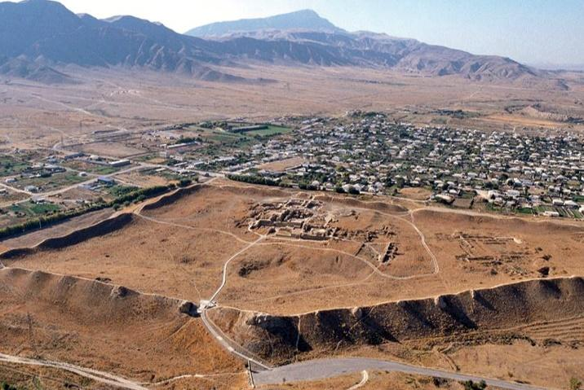
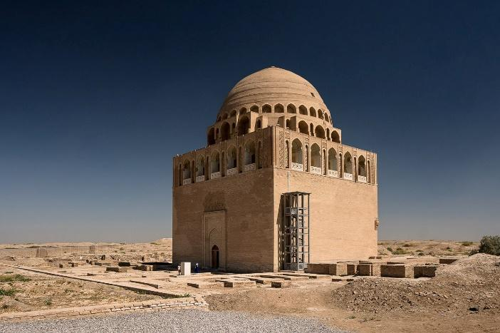
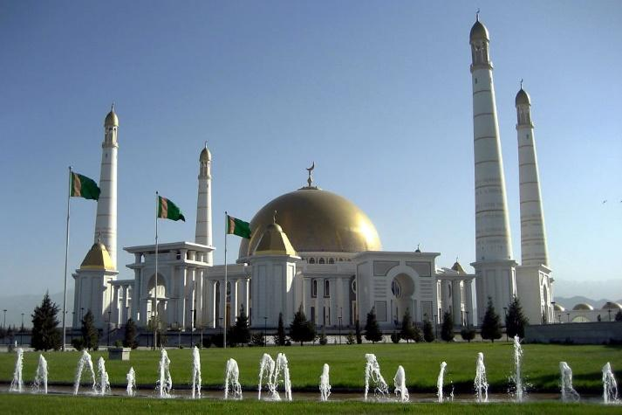

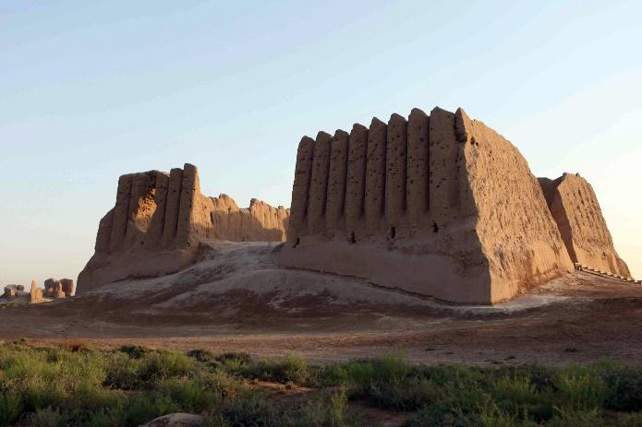

Notes
• The price is based on a minimum group size of 3 participants.
• The itinerary may be adjusted depending on flight schedules, weather conditions, and road conditions.
• The tour can also be organized starting from Ashgabat, Farap, or Shavat land border upon request.

